Horseheath Parish Council Objections to Application CCC/23/110/FUL
This proposal is for a new 11.17 hectare biodigestion plant on land owned by Streetly Hall Estates of which 7.55 hectares will be the plant itself. The site is on the corner of Dean Road and Webbs Lane.
The proposal is to use crops and agricultural waste from farms within the Estate and Grange Farm in Balsham to produce biomethane which is projected to be injected into the gas main locally. In order to avoid additional traffic on Webbs Lane and Dean Road there is a new proposed access directly on to the A1307 to the south across the Roman Road (Via Devana). This section of the Via Devana is not scheduled and an existing farm track crosses the road at the proposed intersection.
The plant itself is in the Parish of West Wickham and Streetly End; the southern 500m of the access track to join the A1307 is in Horseheath Parish as this schematic drawing shows:
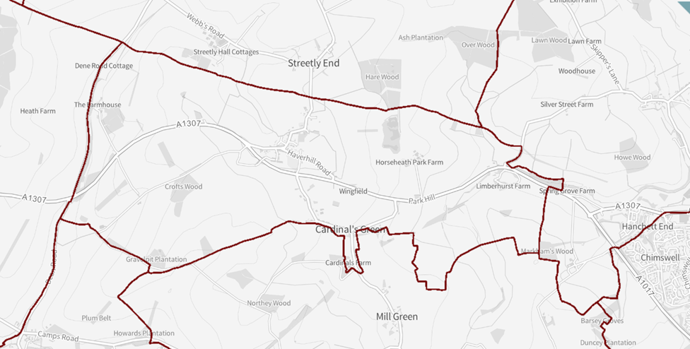
Horseheath Parish
The nearest residences in Horseheath Parish are Dean Road Cottages, Horseheath Lodge and Mill House. The village of Horseheath is approximately 1.2km to the south east.
The application includes assessments of environmental impact, air quality, the historic environment, odour, noise impact, flood, groundwater contamination risk and health risk. It also includes construction plans, transport plans and surface water management plans. The maximum height of the facility will be 18m.
The proposed crop and waste inputs to the digestor will come from Grange Farm, Balsham as well as farms in the Streetly Hall estate. The documents state that between 44 and 53% of the inputs will come from other unspecified farms (p14, Transport strategy, page14, p 3.14). Given the proposal for a larger biodigestion site at Spring Grove Farm at the other end of the Parish it is unclear where all the proposed agricultural crops and waste will come from, suggesting a significant amount of this will need to come from some distance away.
The plant will be designed to use straw or maize as a large part of the wast input and would need conversion for food waste. This is important as there is we understand already a strong local market for straw and other waste going to the biomass power station at Sutton, Ely, typically operating with long contracts to local farms. The applicants aim to use some of this straw output from local farms. The applicants state that current transport projections are based on using local straw. If the applicant is not successful competing against the Sutton plant’s contracts with local farmers much more of the feedstock input we would need to be brought in by HGV from further afield. The applicants have stated publicly that the vehicle projections provided are a minimum because of this. We believe that the transport documents provide optimistic projections and that these should be reviewed again by Highways in the light of the supply situation for feedstock. Actual HGV movements will we contend be higher than those stated; at the public meeting it was suggested that in peak harvest months these could reach 8-11 vehicles per hour using the new A1307 access and crossing the Roman Road.
General – New waste management facilities should be constructed in line with the Cambridgeshire and Peterborough Minerals and Waste Local Plan (CPM&WLP) (adopted 2021). This states that new sites should principally be on brownfield sites and not agricultural land. It also states that although new facilities should be close to major roads, traffic loads should not significantly increase. However the transport statement states that 5,368 large vehicle movements will take place annually, which equates to 10,736 journeys per year on the public highway of which 75% will use the new access road. The remaining 25% of journeys will be made from ‘other farms’ and will therefore access the AD Plant using Dean/Webbs Road which would be accessed via Streetley End, West Wickham or Balsham which include some single lane roads which are wholly unsuited to frequent HGV use. We contend that 10,736 journeys per year represent a significant increase in traffic loads and as above the real number will be significantly more than the documents state.
Landscape – the proposed construction will be very visible from the north west, particularly walking along the Roman Road (which is a well-used bridleway - The Harcamlow Way - in this stretch). The CPM&WLP suggests that sites should be very well screened from the surrounding landscape. We suggest further landscape screening should be considered in this aspect.
Heritage impacts – there appears to be no assessment of any impacts on Horseheath Lodge, the closest Grade 2 listed asset in Horseheath Parish. We suggest the noise and light pollution may significantly impact this asset as the plant is intended to run on a 24 hour basis. Equally, we have not seen air quality and odour assessments for Horseheath Lodge.
Archaeological aspects – we are uncertain that adequate provision has been made to ensure a full and appropriate assessment of the potential investigation of the archaeology of the site (see comments from the County Council Senior Archaeologist).
Impact on the Roman Road – We understand that where sections of a monument are scheduled, any proposed developments impacting non-scheduled parts of the monument should be treated as though they were scheduled. The applicant rejects this for the Via Devana where it is crossed by the proposed new road as the farm track has crossed the bridleway for many years. The data suggest that up to 80-100 HGV/tractor journeys per day may cross the Roman Road – more than one every 10 minutes (stated by the applicant at a public meeting). The bridleway is well used.
There are three issues:
- Damage to the roman road itself – this is assumed to be non-significant since there is an existing farm track. However this crossing has never had the volume of large vehicles proposed in this application
- The impact on users of the bridleway of this number of large vehicles. Users include cyclists and equestrians as well as walkers. There is no policy for mitigation for all of these users. We suggest this crossing presents a health risk from the new crossing traffic and curtails the use of a long standing public asset going back thousands of years.
- This section of the Roman Road will also be impacted by noise, odour and light pollution
Transport and Highway impact – this section of the A1307 is very sensitive to slow moving vehicles and has had a very significant accident history a few hundred metres beyond the limited stretch of road included in the application documents. This has been serious enough for the 50mph speed limit to be imposed 2 years ago, with the iinstallation of average speed cameras. The applicant suggests that these changes have resolved the risks to traffic on the A1307 such that adding a new access point will not alter the risk to current road users. The accident data included in the application is not current (a fatal accident is not included) and we suggest that the traffic survey, undertaken as it was at the end of November, may not accurately reflect the traffic on the road throughout the year.
Currently work is underway to stop traffic turning right from the A1307 in to either Bartlow Road or Dean Road, 500 metres to the west of the proposed access. The proposed transport strategy for the development projects, on average,18 HGV/tractor movements turning in to and out of the new access road per day. As argued above we believe (as stated by the applicant at a public meeting) the actual number will be much higher, possibly 80-100 vehicles per day during summer months. There is no discussion of the need for this new HGV/tractor traffic to enter and exit the new road from both directions on the A1307. However the crop waste will be brought from both the east and west.
It would not be credible to permit a significant number of HGVs and tractors to cross the flow of traffic into this new access road when this is being prevented 500 metres away in to Bartlow Road and Dean Road. We contend that any new access should include a left turn in to and out only. However we are concerned that this would result in a significant increase in traffic in both directions, to seek to move in to the correct lane, this would result in a HGV seeking to go round the new Linton roundabout roughly every 10 minutes. There is no equivalent means of turning round in the direction of Horseheath until the roundabout in Haverhill is reached. We are concerned that some drivers might choose to drive through Horseheath or Cardinals Green to change direction. There are sections of this route (outside Horseheath Park Farm) which are currently 60mph, suggesting traffic flows would be impeded by this increased volume of slower moving HGVs and Tractors.
We contend that the new access road will present a risk of increasing road traffic accidents at the junction with the A1307 and will impede the flow of traffic along this already congested road. We do not accept the stated figures in the application and believe that Highways should re-evaluate the proposed traffic numbers. This application will significantly and materially impact traffic flows on the A1307 with a potential increase in poor traffic flow and accidents. We suggest it is not acceptable.
Environmental concerns – There does not appear to be any consideration of the potential for infestations of flies or vermin to affect local residential dwellings. Equally, there does not seem to be a consideration of the potential for methane discharge and any mitigation strategy for this eventuality.
The public meeting heard that all other UK plants have been fined by the Environment Agency for breaching their licenses and that plants such as this release ammonia and other unwanted chemicals, some of which are carcinogenic, in to the environment. This was not contested by the applicant.
The odour survey indicates that odour will be negligible once sites are operational however this view is at variance with research that highlights ongoing disputes between locals, councils and the Environment Agency regarding ‘unbearable smells’ emanating from such AD Plants, spanning from 2019 to current disputes relating to recently installed plant.
There is an assumption that the bio methane produced by the AD Plant will be injected locally into the gas main that runs parallel to the Roman Road mitigating up to 10% or 1074 journeys, however approval for a local injection point is far from certain, as ‘bio-gas to grid’ is usually subject to filtering and blending with propane to achieve a consistent calorific value with the grid gas characteristics. Should the bio methane require to be shipped by road to a grid injection facility, some distance from the plant, then that would have the potential to change the project carbon balance to negative.
There is however no means of determining, at this stage, how finely poised the project zero balance may be as no carbon balance information has been submitted with the application. Therefore it is impossible to determine whether this project has an operational positive or negative carbon footprint.

